UNIT-3
SPECIAL OSCILLOSCOPES

- Dual trace oscilloscope
- 2) Sampling oscilloscope
- 3) Storage oscilloscope
- 4) Digital Read out oscilloscope
- 5) Digital storage oscilloscope
- 6) Measurement of capacitance & inductance
- 7) Standard specification of CRO
- 8) Probes for CRO – active, passive
- 9) Attenuators
- 10) Out put power meters – Audio, RF, micro wave & opticals

- Dual trace oscilloscope:

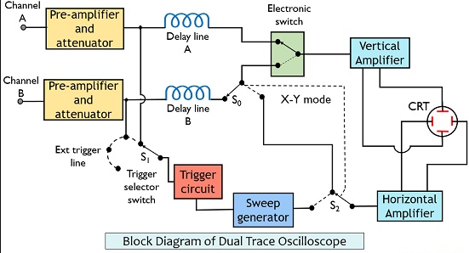

- In this, same electron beam is used to generate two traces, by means of electronic switching of two separate i/p signals.
- Two signals are displayed simultaniously
- There are two vertical i/p circuits marked as channel A & channel B with identical pre-amplifier
- Each channel has its own calibrated attenuator positioning control so that amplitude of each signal can be independently adjusted.
- The o/p’s of the pre-amps are fed to an electronic switch which alternatively connects them to the main vertical amplifier.

- Modes of operation: The mode control switch enables the electron switch to operate in following modes.

Alternate mode:

- The electron switch alternately connects the main vertical Amp to channel A &channel B at the start of each new sweep cycle.
- The switching rate of electron switch is synchronized to the sweep rate so that the CRT spot traces the channel A signal on one sweep and channel B signal on the succeeding sweep.
- The switch adds a different dc component to each signal to directs the beam alternately to the upper & lower half of the screen.
- The sweep trigger is available from channel A,(or)B and trigger pick_off takes place before the electron switch.This arrangement maintains the correct phase relationship between signals A&B.
- This screen will show a steady display of both waveforms only when the sweep speed is must greater than the decrease time of CRT phosphor.
- The display is blanked during fly back & hold_off periods.

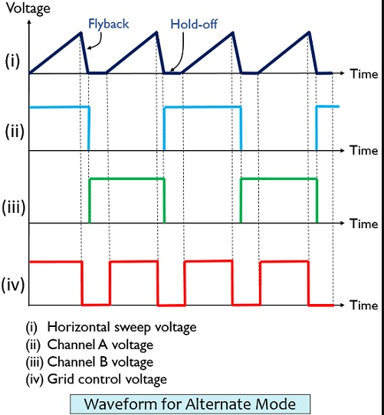

b)CHOP mode:
- In this mode, the electron switch freely runs at higher freq of the order of 100-500 kHZ, entirely independent of freq of sweep g.
- The switch successfully connects small segments of A & B waveforms to main vertical Amp at a relatively fast chopping rate of 500KHZ.
- The display will show a continuous line for each channel only when the chopping rate is much greater than horizontal sweep rate.
- If sweep rate approaches chopping rate, then the individual segments will be displayed & the alternate mode can be preferred in this case.

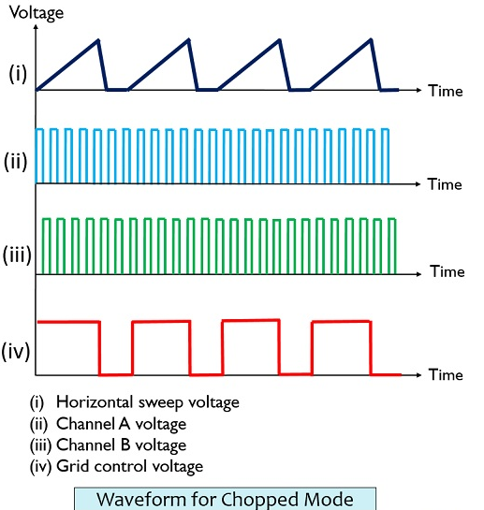

3) Add mode:
In this model, signal image can be displayed by the addition of signals from CH-A &CH-B.i.,e(A+B)

4) X-Y mode:
In this mode, the sweep generator is disconnected from Horizontal Amp & channel B is connected to horizontal Amplifier
Since both pre-Amps are identical & have same delay time, accurate x-Y measurements can be made.

Electronic switch:
The electron switch is a dc device that enables two signals to be displayed simultaneously on the screen by a single gun CRT.
- Each signal is applied to a separate gain control & gate stage
- The gates are alternately biased to cut off by square wave signal.
- There fore only one gate is in ON state to pass its signal at any given time.
- The heights of the individual signals can be applied by using gain control R1&R2
- The trace can be moved up (or) down by the control R. The trace can be overlapped for easy comparision.
- Sampling oscilloscope:

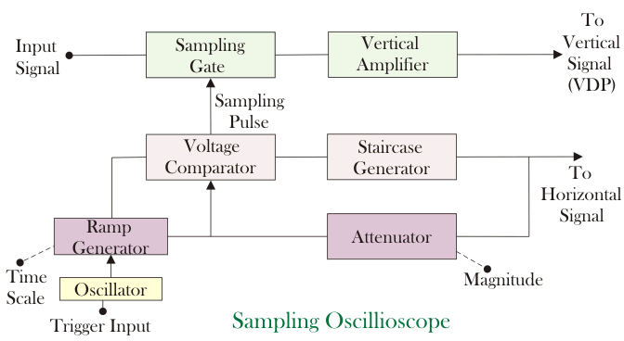

- An ordinary oscilloscope has a BW of 10MHZ.
- The HF performance can be improved by means of sampling the i/p w/f and reconstructing its shape from the sample the signal to be observed is sampled and after a few cycles the sampling point is advanced & another sample is taken.
- The shape of the w/f is reconstructed by joining the sample level together.
- The sampling freq may be low as 1/10th of i/p signal freq.
- As many as 1000 samples are used to reconstruct the original w/f. Therefore the display is made up from 1000 dots of luminescence.
- The horizontal deflection of the electron beam is obtained by application of a static case w/f to X-deflection plates.

Operation:
  - The i/p w/f is applied to the sampling gate. The i/p w/f is sampled whenever the gate is open. The sampling must be synchronized with i/p signal frequency.
  - At the beginning of each sample cycle the trigger pulse actives an oscillator & a linear ramp voltage is generated.
  - The ramp voltage is applied to a voltage comparator, which compares the ramp voltage & staircase voltage generated by stair case generator.
  - When two voltages are equal in magnitude the static case advances one step and sampling pulse is generated which opens the sampling gate.
  - The sampled signal is then applied to vertical amplifier and to y-deflection plates.
  - The out put of stair case generator is also applied to x-deflection plates. During each step of staircase, the spot moves horizontally on the screen.
  - After certain no of pulses about 500, the stair case generator resets .For smaller size of steps of the stair case generator, the no of samples are high &resolution is high.
Advantages:
- The sampling method transforms the i/p signal in to lower freq range.
- Very high freq performance can be achieved.
- By controlling the size of steps of stair case generator, we can increase no of samples &thus resolution.
- We can decrease oscilloscope with high BW, high sensitivity.
- Dis-advantages:
- Cannot be used for displaying transient waveform

3) Storage oscilloscope:
- The conventional scope has a display with a phosphor persistence ranging from few micro seconds to few seconds.
- The storage oscilloscopes are capable of returning the image on the screen for a long time, dependent of phosphor persistence.
- Two storage techniques are used in oscilloscope CRT s-mesh storage &phosphor storage.
- A mesh storage CRT uses a dielectric material (magnesium flouride) deposited on a storage mesh as the storage target , a collector mesh flood guns and a collimeter in addition to all elements of standard CRT.
- The storage mesh makes use of a property known as secondary emission. When the electron beam strikes the target surface an energy transfer takes place which separate other electrons from the surface of the target. This process is called as secondary emission.
  - (more electrons are emitted than absorbed by the material and hence a net +ve charge results at the surface)
- Inorder to store a trace:
- Assume that storage surface is uniformly charged (to some –ve potential)& write gun electron beam will hit the storage target.
- The areas of storage surface hit by deflecting electron beam lose electrons, which are collected by collector mess.Hence write beam deflection pattern is traced on the storage surface as +ve charge pattern.
- Since insulation of the dielectrice material is high ,it prevents loss of charge for considerable length of time and hence the pattern is stored.
- To view the stored trace, a separate electron gun called is flood gun is used when the write gun is turned OFF .
- The flood gun emits a flood of low velocity electrons, which move towards collector mesh.
- The collimator helps to align the flood electrons so that the flood gun electrons are distributed evenly over the surface of storage target and causes the electrons to approach the storage target perpendicularly as shown in fig(2).
- When electrons penetrate beyond the collector mesh, the encounter either +vely charged eas of region where no trace has been stored.
- The +vely charged areas of storage target allows the electrons to pass through to the post accelerated region & then the target phosphor and there by reproduced to stored image on the screen.
- The –vely charged region repels the flood electrons back to the collector mesh as shown in fig.
- Now the CRT will display the signal and it will remain visible as long as flood guns operate .To erase the pattern on the storage mesh, a –ve voltage is applied to neutralize the stored the charge.
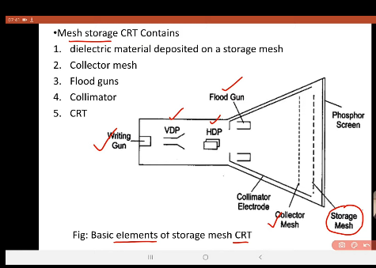

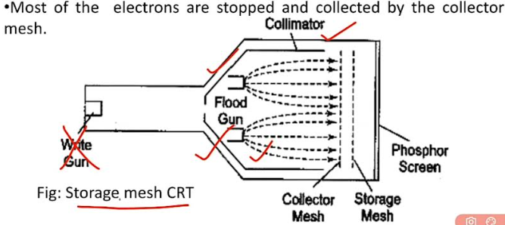

4. Digital storage oscilloscope:

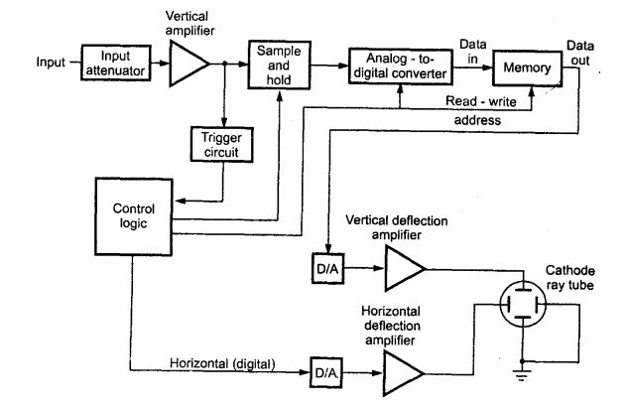

1.The input signal is applied to the amplifier and attenuator section.
2.The oscilloscope uses same type of amplifier and attenuator circuitry as used in the conventional oscilloscopes.
3.The attenuated signal is then applied to the vertical amplifier.
4.To digitize the analog signal, analog to digital (A/D) converter is used.
5.The output of the vertical amplifier is applied to the A/D converter section.
6.The successive approximation type of A/D converter is most oftenly used in the digital storage oscilloscopes.
7. The sampling rate and memory size are selected depending upon the duration & the waveform to be recorded.
8.Once the input signal is sampled, the A/D converter digitizes it.
9. The signal is then captured in the memory.
10. Once it is stored in the memory, many manipulations are possible as memory can be readout without being erased.
The digital storage oscilloscope has three modes:
1. Roll mode
2. Store mode
3. Hold or save mode.
Screen continues wave form can be displayed.
The DSO following mode of operations
1. Roll mode : this is used observe the fast varying signals
2. Store mode : it is called as “Refresh” mode and is most commonly used.
3. Hold and save mode: this mode is used to lock to previously saved signal.
Advantages
i) It is easier to operate and has more capability.
ii) The storage time is infinite.
iii) The display flexibility is available. The number of traces that can be stored and recalled depends on the size of the memory.
iv) The cursor measurement is possible.
v) The characters can be displayed on screen along with the waveform which can indicate waveform information such as minimum, maximum, frequency, amplitude etc.
vi) The X-Y plots, B-H curve, P-V diagrams can be displayed.
vii) The pretrigger viewing feature allows to display the waveform before trigger pulse.
viii) Keeping the records is possible by transmitting the data to computer system where the further processing is possible
ix) Signal processing is possible which includes translating the raw data into finished information e.g. computing parameters of a captured signal like r.m.s. value, energy stored etc.
Advantages:

- Storage capacity
- We can use normal CRT
- We can get data at any time
- The wave form can be repetitively read out.
- A cross hair cursor can be positioned at any desired point on the wave form & the voltage & time values can be displayed n the screen.

Disadvantages:
- Band width & speed depends on ADCS.

Applications:
- The DSO is used to give the visual representation for a target of radar such as aeroplane, ship etc.
- The DSO can be used to check the faulty components in various circuits.
- It can be used in medical field.
- The DSO can be used to measure ac as well as dc voltages and current.
- It can be used to analyze TV waveforms.
- The digital storage oscilloscope (DSO) is used to observe the radiation pattern generated by the transmitting antenna oscilloscope.
- The DSO used to save signals, so that it can be compared to or processed.
- The DSO can be used to measure the inductance, capacitor.
- It can be used to measure frequency, time period, time interval between signals etc.
- It can be used to observe the V-I characteristics of diodes, transistors.

The applications of the DSO are
• It checks faulty components in circuits • Used in the medical field • Used to measure capacitor, inductance, time interval between signals, frequency and time period • Used to observe transistors and diodes V-I characteristics • Used to analyze TV waveforms • Used in video and audio recording equipment’s • Used in designing • Used in the research field • For comparison purpose, it displays 3D figure or multiple waveforms • It is widely used an oscilloscope

Oscilloscope Probes
Oscilloscope Probes are a conducting wire which is used to establish a connection between the circuit under test and the measuring instrument. While connecting the test circuit, the probe does not alter, load or disturbs the circuit and signal conditions to be analyzed.
Any signal going to the oscilloscope will first pass through the probe. Therefore bandwidth of probes combines with the bandwidth of CRO. The probe bandwidth must be higher than the oscilloscope bandwidth. The probe bandwidth is chosen to at least 10 times of CRO frequency.
The probe should have high impedance. The probe bandwidth should be as high as possible. It should be about 10 times the bandwidth of the oscilloscope. The ideal oscilloscope probes offer the following key attributes:
- Ease of connection
- Absolute signal fidelity
- Zero signal source loading
- Complete noise immunity
The general diagram of the oscilloscope probes is shown in the Figure below.
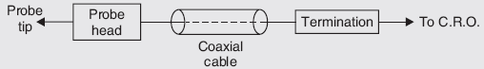

The probe tip is the signal sensing circuit. It may be passive or active. If it is passive, it consists of the resistors and capacitors. If it is active, it consists of active components like a FET source follower circuit.
The probe cable is a special coaxial type (with a resistive center conductor to damp out ringing), with quite-effective shielding. Its capacitance is greater than that of open-wire, and in some cases, such a probe is satisfactory.
The probes are of many types, they are given below:
- Direct probe
- Isolation Probe
- High impedance or 10: 1 Probe
- Active Probes
- Passive Probe

Direct Probe 1:1
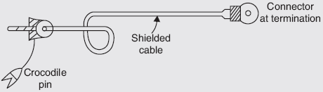Direct Probe 1:1
- These are the simplest type of probes.
- These probes terminate with banana tips or other types of tips.
- The tip of the probe has crocodile clips or other means of connecting the oscilloscope to the test circuit.
- The probes use shielded co-axial cable.
- This type of probe does not provide any improvement in the input impedance. They are called as “1X probes”.
- The input impedance of the vertical amplifier of a general-purpose CRO is 1 MΩ and input capacitance is 30 pF. When the direct probe is used, the input resistance remains constant at 1 MΩ. But the input capacitance of the oscilloscope gets added to the probe capacitance.
- The effect of shunt capacitance can be minimized by using a carbon resistance in series with the test leads. Such probes are called isolation probes.

Isolation Probe
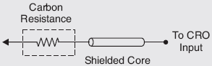Isolation Probe
- The input capacitance of the oscilloscope and the stray capacitance of the test lead are very high. It causes the sensitive circuit to break into oscillation when CRO is connected.
- This effect can be prevented by an isolation probe. The isolation probe is made by placing a carbon resistor in series with a test lead.
- An isolation probe is employed to avoid the undesirable circuit loading effect of the shielded probe.
- This probe causes a slight change in the amplitude of the waveform and a slight change in the wave shape.
- To avoid this possibility, a high impedance compensated probe, called a low capacitance probe or a 10:1 probe is used.

High Impedance or 10: 1 Probe
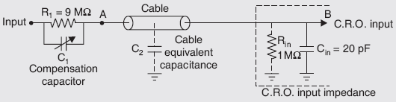High Impedance or 10: 1 Probe
- This probe is also known as a passive voltage probe.
- The basic function of this probe is to increase the input impedance and reduce the effective input capacitance of an oscilloscope.
- This probe head uses a parallel resistor and capacitor combination.
- The resistance R1 is shunted by an adjustable capacitor C1. This capacitor is called a compensating capacitor.
- The resistor R1 and C1 are designed such that, input increases by factor 10 and input capacitance decreases by a factor of 10. Therefore this combination of R₁ and C₁ is called x10 probe.
- Let C2 be the probe cable equivalent capacitance. The input resistance and capacitance of CRO can be referred to as R_{in} and C_{in}. The typical values of R_{in} and C_{in} are 1 MW and 20 pF.

Active Probe
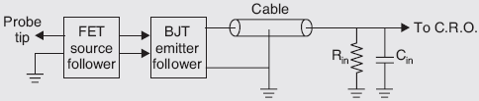Active Probe
- The active probes are used for connecting fast-rising and high-frequency signals.
- These probes are very useful for small signal measurements as their attenuation factor is very small.
- The active probe consists of an active element like FET source follower circuit and BJT emitter follower circuit along with a co-axial cable termination.
- FET source follower provides high input impedance which reduces loading effect.
- Following the FET source, there is a BJT emitter follower. It drives the cable and provides impedance matching.
Advantages:
1.less attenuation is offered
2.high input impedence
3.capacitance values are also low
4.useful for small sugnal measurements

Dis advantages:
1.the range of signals that can be handled by the probe is limited to the dynamic range of the FET amplifier.
2.more expensive and bulky
- 3.requires power supply

What is a Passive (Modular) Probe?
Passive (Modular) Probes are the most common type of oscilloscope probe. Passive probes provide the ruggedness and wide dynamic range suitable for visualising signals over a broad range of applications. Passive probes are widely considered "general purpose" probes and are well suited for low frequency signals as circuit loading is minimised.

Example Applications:
- Passive Probes: Quick Quantitative Measurements
- Working In DC Low Frequency Range
- Typically a 500 MHz Bandwidth Maximum
Passive probes are the most commonly used probes for taking general-purpose measurements. Passive probes are constructed using wires, connectors, a housing, and, if required, compensation or attenuation resistors or capacitors. No active components—such as transistors or amplifiers—are used within these types of probes. Generally speaking, passive probes are easy to use, relatively inexpensive, and fairly rugged.
Passive probes are typically available in the following configurations:
- 1×: no attenuation
- 10×: factor-of-10 attenuation
- 100×: factor-of-100 attenuation
- 1000×: factor-of-1000 attenuation
Attenuation probes serve to multiply the voltage measurement range of the oscilloscope by using an internal resistor that, when used in conjunction with the input resistance of the scope, creates a voltage divider. As an example, a typical 10× probe houses an internal 9 MΩ resistor that, when used with a 1 MΩ scope, creates a 10:1 attenuation ratio at the scope's input channel. This means that the displayed signal on the scope will be 1/10th the magnitude of the actual measured signal. This attenuation feature is useful for the following reasons:
- It allows for the measurement of a signal that might exceed the limits of the oscilloscope.
- The attenuation circuitry results in higher resistance (generally a good thing) and lower capacitance, which is important for high-frequency measurements.
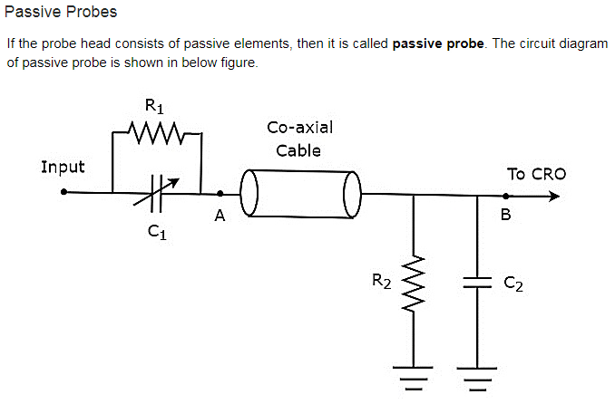

Figure 5. Typical schematic of a 10× passive probe.

Problem 1:
A High impedance probe with 9 Mohm resistance and 4 pF capacitance is connected to an oscilloscope with an input resistance of 1 Mohm. When the probe was connected, the effective capacitance is decreased to 3.6pF. Find
- The capacitance of the Oscilloscope
- The attenuation of the probe
R1=1Mohm
R2=9Mohm
C1=4Pf
C2=3.6Pf
i.Capacitance of oscilloscope Ceq=C1*C2/C1+C2
V0=VixR2/R1+R2
ii.attenuation of probe=Vi/V0=R1+R2/R2
=10/9

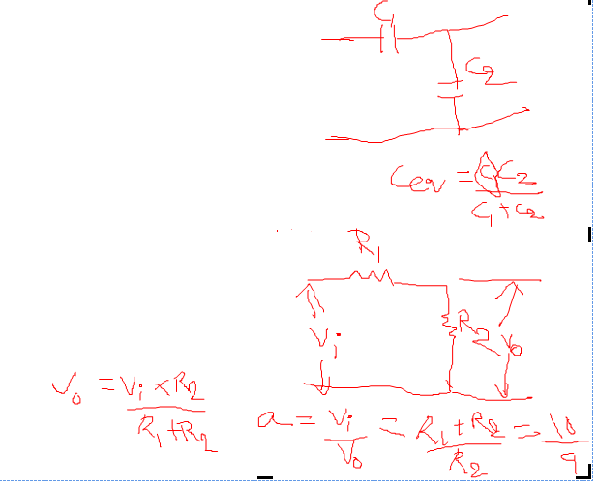

Frequency measurements using lissajous figure:
1.Tangent Technique :
-From the given lissajous fig, draw the both horizontal & vertical tangent lines which touches the peaks of the lissajous figure.
-Count the no.of peaks touches by both horizontal and vertical tangent lines
-A closed point touch should be counted as a full peak
-A open point touch should be counted as a half peak
-The unknown frequency ‘ f_{Y} ‘ can be calculated by using
f_{y} = f_{x} * (no.of peaks touched by horizontal tangent line)
(no.of peaks touched by vertical tangent line)

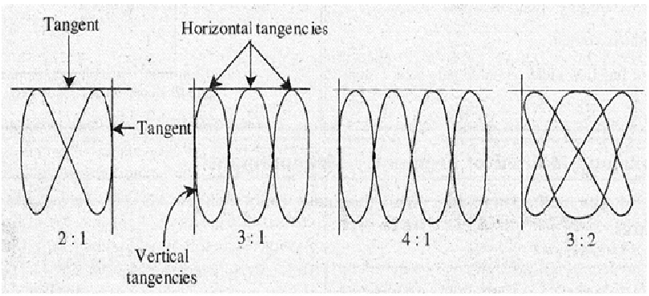
2. Intersection Technique:
For the given lissajous fig, draw the both horizontal and vertical lines which pass through the lissajous fig
-Never draw any line via pre-existing intersection point
-count the no.of intersections made by both horizontal and vertical line
-The unknown frequency ‘f_{y} ‘ can be calculated by
f_{y} = f_{x} *(horizontal intersection points)
(vertical intersection points)

